Periodic Tessellation
# Source: AI Source: Provided by: [Data Path: Persons Table -> ID Column: 1, Name_En Column: Motasem Essam] -> From: [ChatGPT] on [7/25/2026]
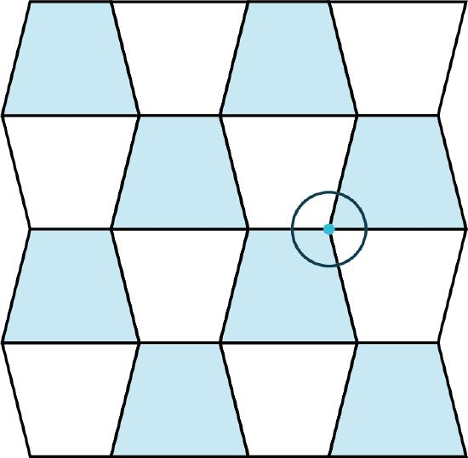
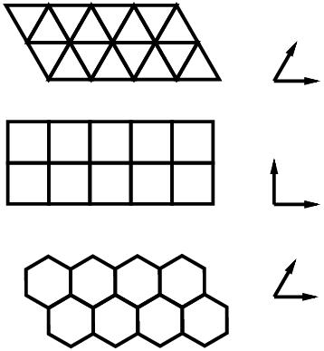
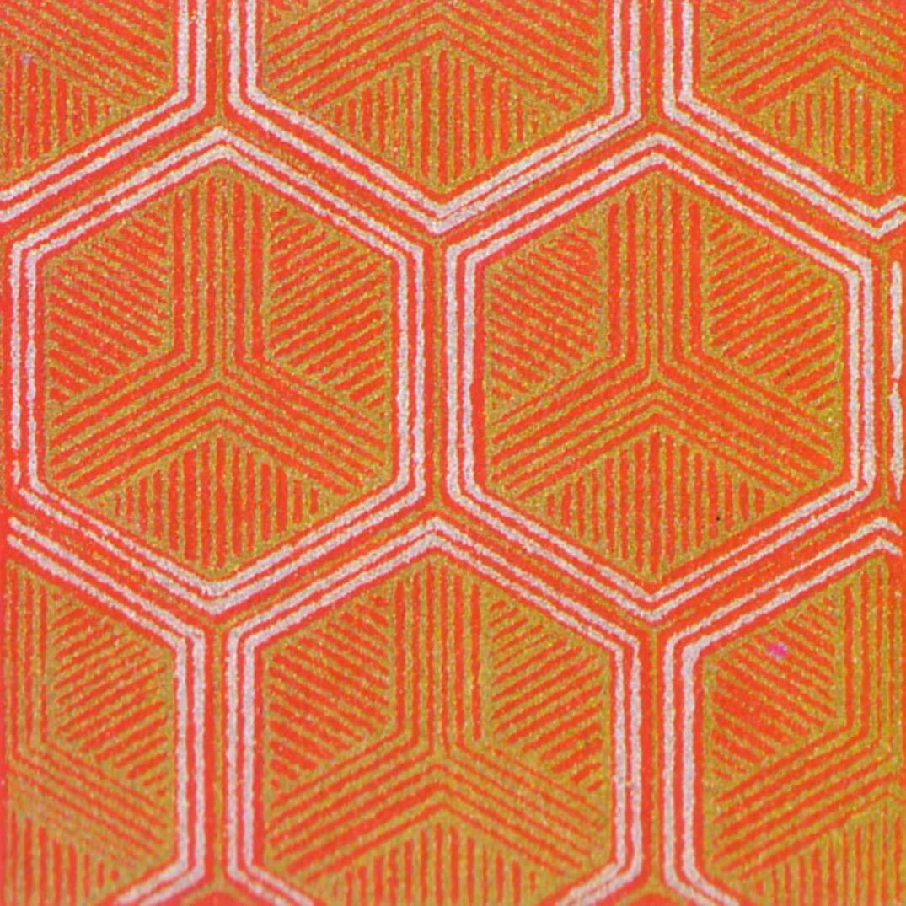
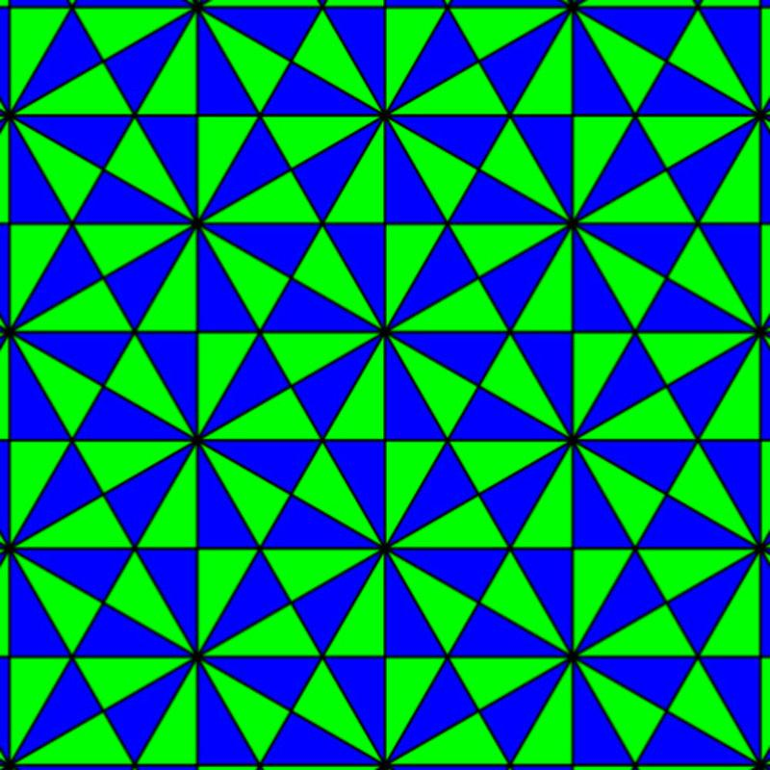
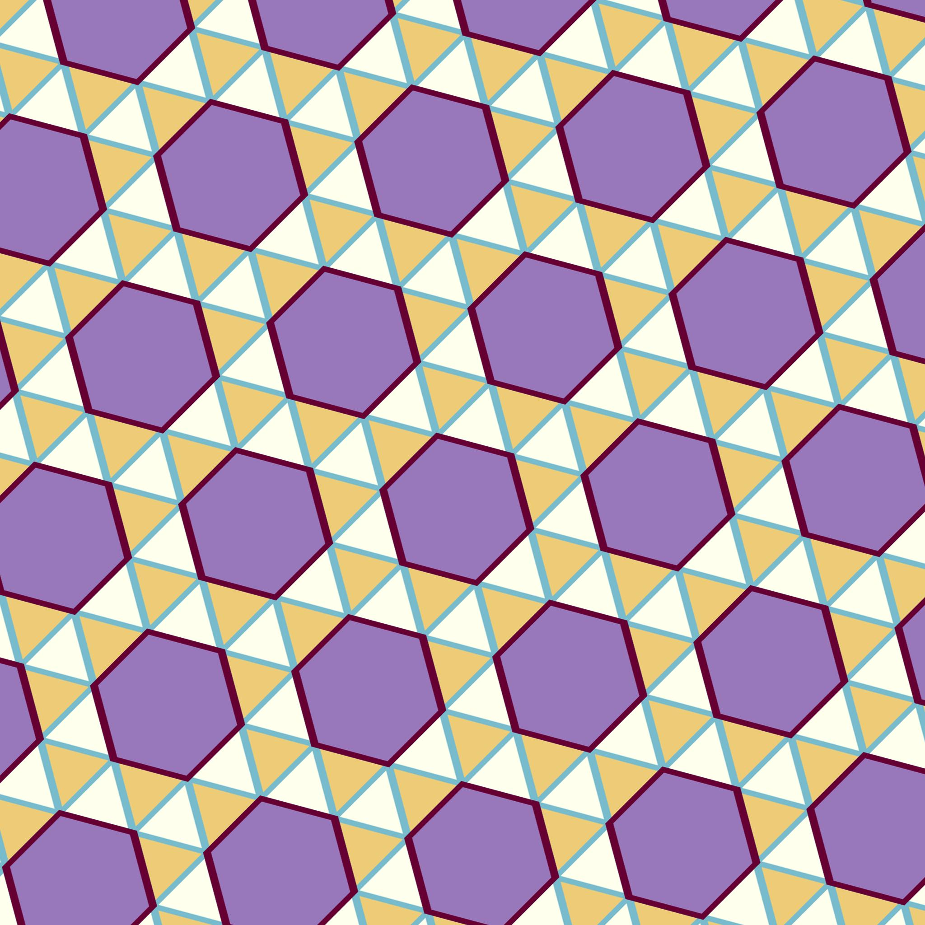
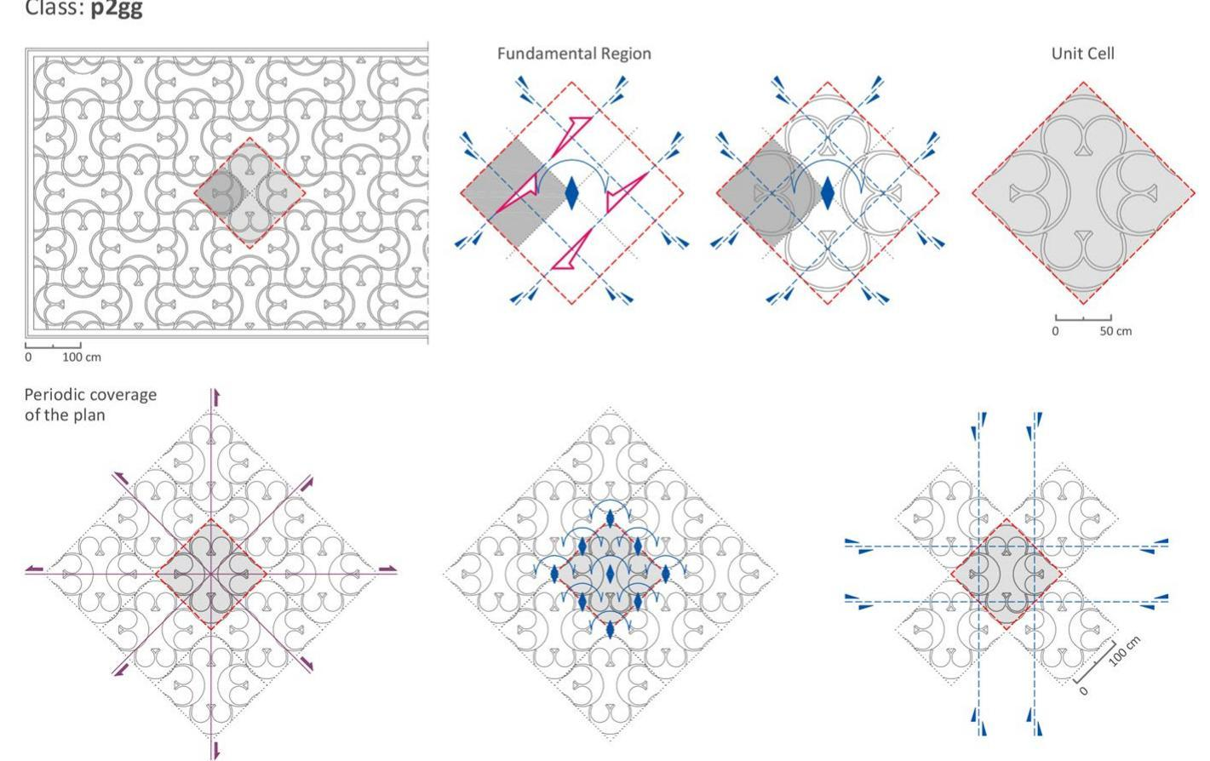

Definition
# Source: AI Source: Provided by: [Data Path: Persons Table -> ID Column: 1, Name_En Column: Motasem Essam] -> From: [ChatGPT] on [7/25/2026]
A Periodic Tessellation is a tessellation whose entire pattern repeats regularly through translations in one or more directions.
In other words, there is a finite repeating unit or fundamental pattern that can be translated repeatedly to reproduce the entire tessellation.
The defining property is:
$$\boxed{\text{The tessellation has translational symmetry.}}$$
A translation moves every point of the pattern by the same displacement while leaving the overall tessellation unchanged.

Purpose
# Source: AI Source: Provided by: [Data Path: Persons Table -> ID Column: 1, Name_En Column: Motasem Essam] -> From: [ChatGPT] on [7/25/2026]
Periodic tessellations are used to:
- Study repeating geometric patterns.
- Analyze translational symmetry.
- Identify fundamental regions and repeating units.
- Classify plane patterns.
- Model regular structures in mathematics, architecture, and materials science.

Fundamental Elements

1. Tile
# Source: AI Source: Provided by: [Data Path: Persons Table -> ID Column: 1, Name_En Column: Motasem Essam] -> From: [ChatGPT] on [7/25/2026]
The individual shape used to cover the plane.
A periodic tessellation may use:
- One type of tile.
- Multiple types of tiles.
- Regular polygons.
- Irregular polygons.

2. Repeating Unit
# Source: AI Source: Provided by: [Data Path: Persons Table -> ID Column: 1, Name_En Column: Motasem Essam] -> From: [ChatGPT] on [7/25/2026]
A Repeating Unit is the smallest region that can be translated to reproduce the entire pattern.
For example:
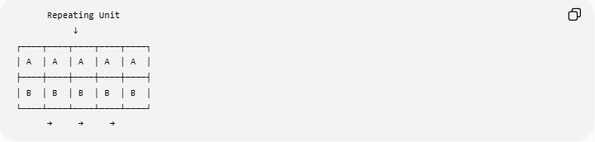
Repeating Unit
↓
┌────┬────┬────┬────┬────┐
│ A │ A │ A │ A │ A │
├────┼────┼────┼────┼────┤
│ B │ B │ B │ B │ B │
└────┴────┴────┴────┴────┘
→ → →

3. Translation
# Source: AI Source: Provided by: [Data Path: Persons Table -> ID Column: 1, Name_En Column: Motasem Essam] -> From: [ChatGPT] on [7/25/2026]
A translation shifts the pattern by a fixed vector:
$$\boxed{T\left(x , y\right)=\left(x , +ay+b\right)}$$
where $a$and $b$determine the translation.

Translational Symmetry
# Source: AI Source: Provided by: [Data Path: Persons Table -> ID Column: 1, Name_En Column: Motasem Essam] -> From: [ChatGPT] on [7/25/2026]
The defining characteristic of periodic tessellations is translational symmetry.
If a tessellation is unchanged after a non-zero translation vector $v$, then:
$$\boxed{T_{v}\left(P\right)=P}$$
where $P$represents the entire pattern.
For a two-dimensional periodic tessellation, there are typically two independent translation directions.
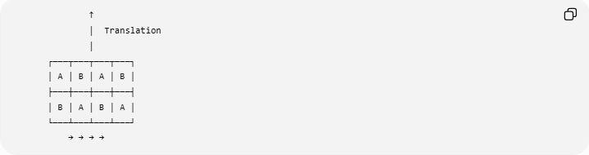
↑
│ Translation
│
┌───┬───┬───┬───┐
│ A │ B │ A │ B │
├───┼───┼───┼───┤
│ B │ A │ B │ A │
└───┴───┴───┴───┘
→ → → →

Classification of Periodic Tessellations
# Source: AI Source: Provided by: [Data Path: Persons Table -> ID Column: 1, Name_En Column: Motasem Essam] -> From: [ChatGPT] on [7/25/2026]
Periodic tessellations can be classified according to the types of tiles and their symmetry.
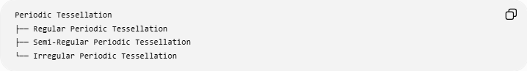
Periodic Tessellation
├── Regular Periodic Tessellation
├── Semi-Regular Periodic Tessellation
└── Irregular Periodic Tessellation
This classification can overlap with the earlier tessellation classification.
For example:
- A square tessellation is regular and periodic.
- A semi-regular $4.8.8$tessellation is semi-regular and periodic.
- An irregular repeating pattern can be irregular and periodic.
Therefore, periodic describes the repetition of the whole pattern rather than the regularity of its tiles.

Regular Periodic Tessellation
# Source: AI Source: Provided by: [Data Path: Persons Table -> ID Column: 1, Name_En Column: Motasem Essam] -> From: [ChatGPT] on [7/25/2026]
The three regular tessellations are periodic:
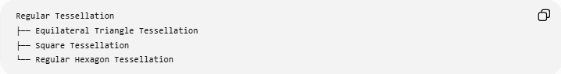
Regular Tessellation
├── Equilateral Triangle Tessellation
├── Square Tessellation
└── Regular Hexagon Tessellation
Each has a repeating unit that can be translated indefinitely.
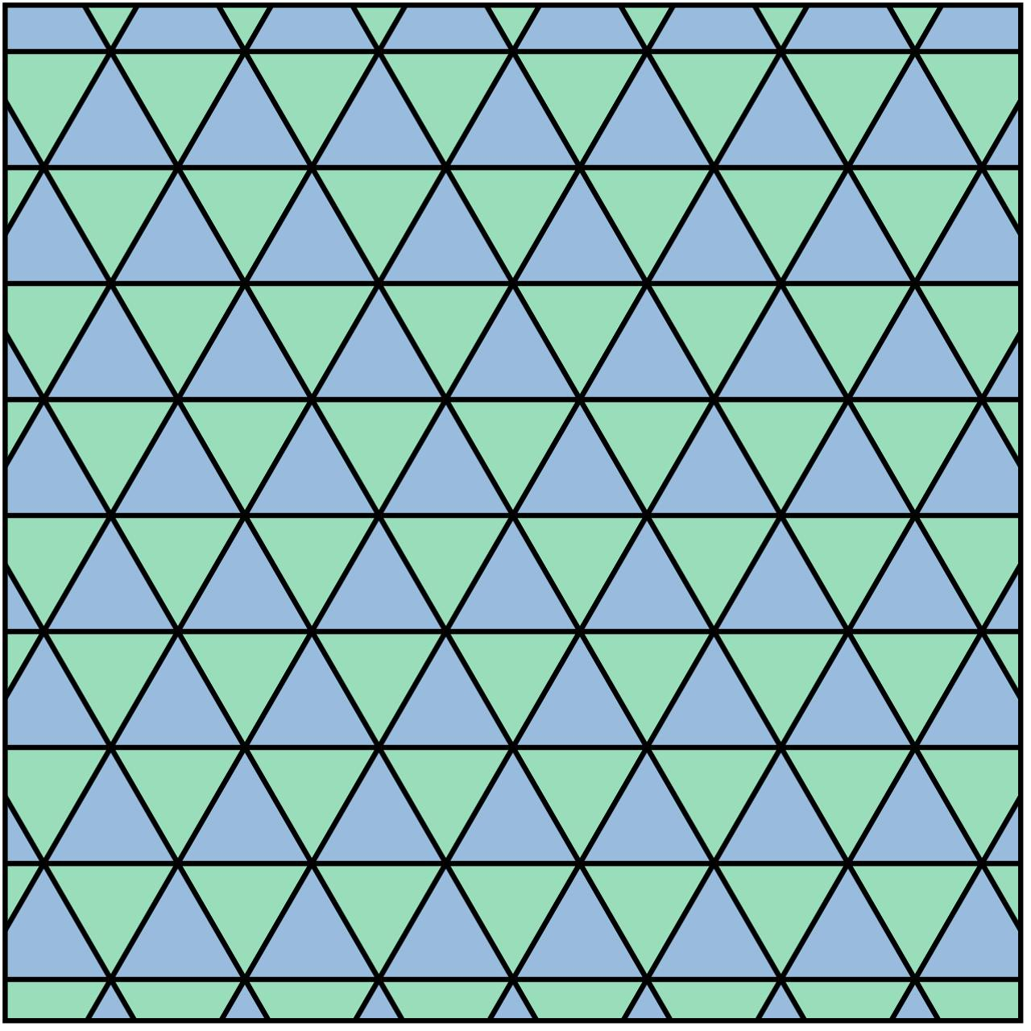
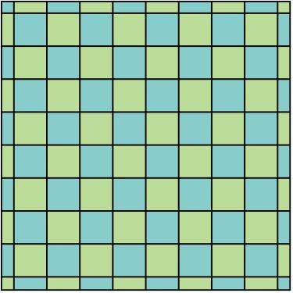
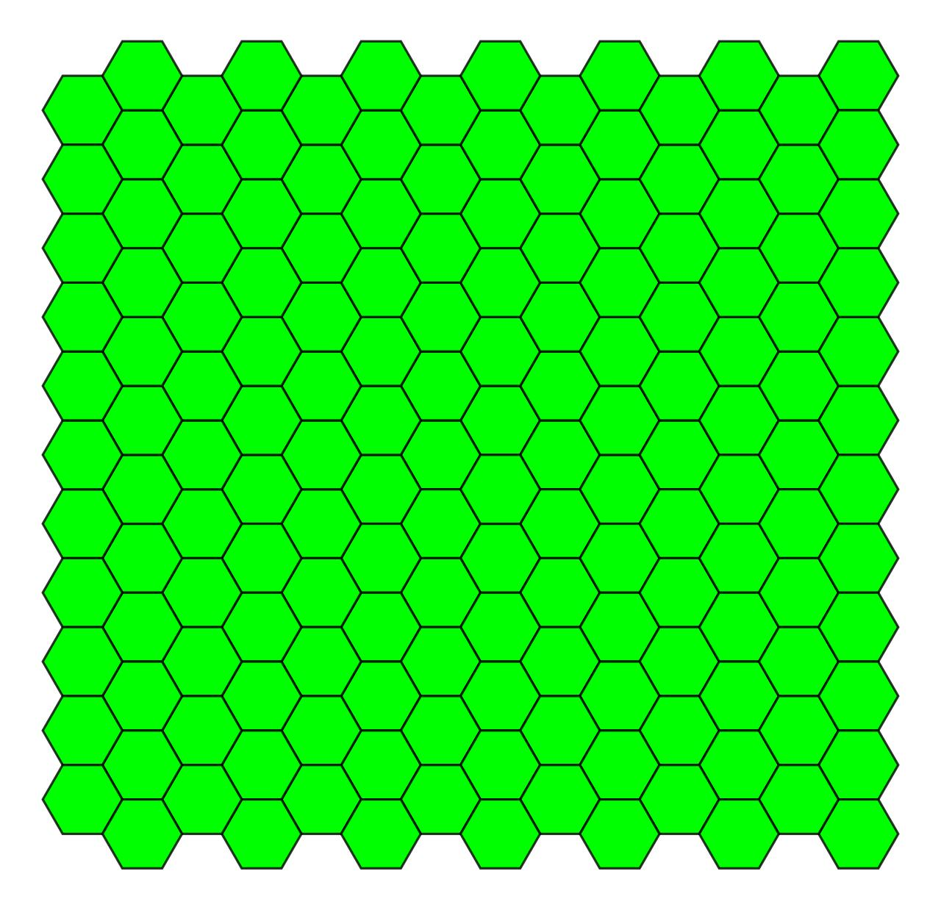
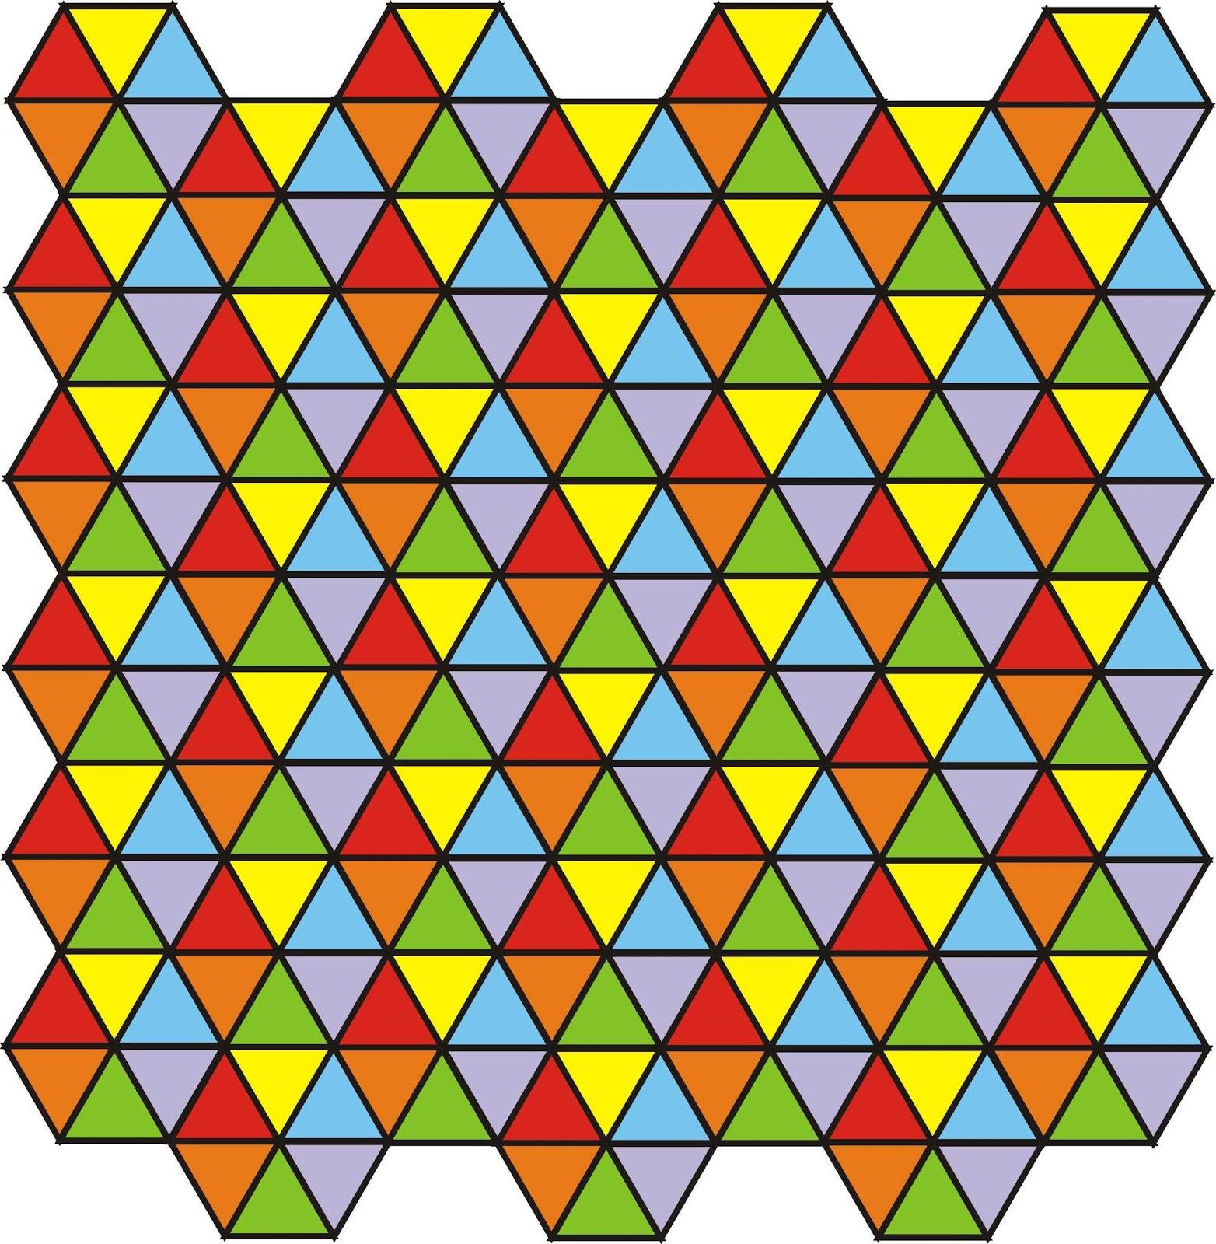
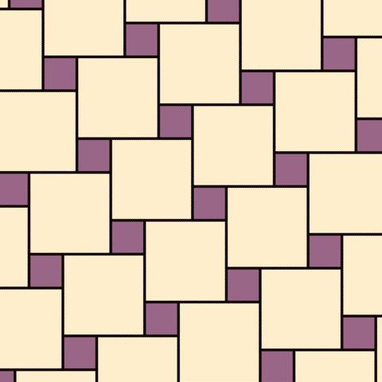
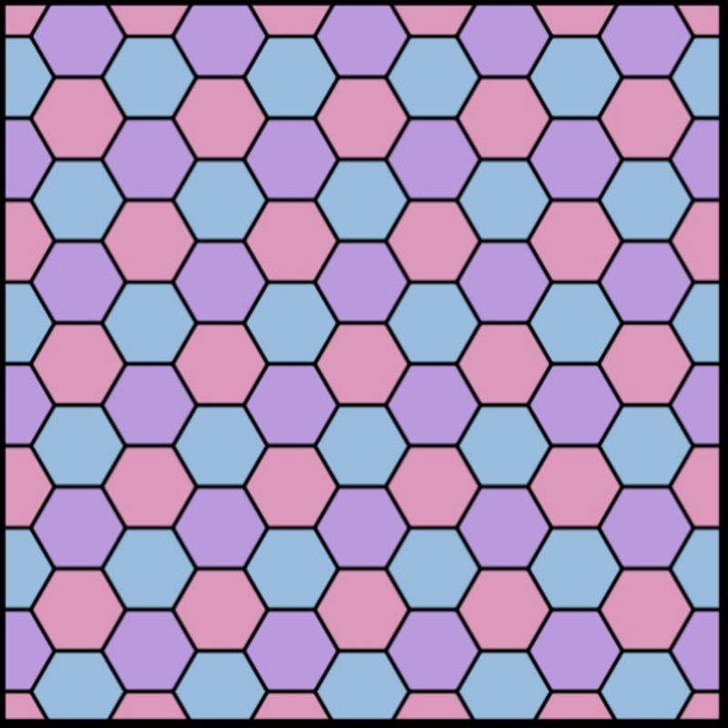

Semi-Regular Periodic Tessellation
# Source: AI Source: Provided by: [Data Path: Persons Table -> ID Column: 1, Name_En Column: Motasem Essam] -> From: [ChatGPT] on [7/25/2026]
The eight semi-regular tessellations are also periodic.
Examples include:
$$\boxed{3.6.3.6} \\ \boxed{4.8.8} \\ \boxed{4.6.12}$$
Their repeating structure can be translated across the plane.

Irregular Periodic Tessellation
# Source: AI Source: Provided by: [Data Path: Persons Table -> ID Column: 1, Name_En Column: Motasem Essam] -> From: [ChatGPT] on [7/25/2026]
An irregular tessellation can also be periodic.
For example, an irregular polygon may be repeated by translation:
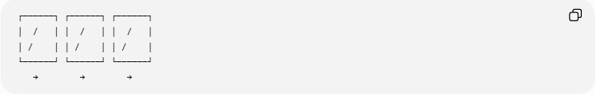
┌──────┐ ┌──────┐ ┌──────┐
│ / │ │ / │ │ / │
│ / │ │ / │ │ / │
└──────┘ └──────┘ └──────┘
→ → →
The individual tile does not need to be regular.
Thus:
$$\boxed{\text{Periodic}≠\text{Regular}}$$

Periodic vs Non-Periodic Tessellation
# Source: AI Source: Provided by: [Data Path: Persons Table -> ID Column: 1, Name_En Column: Motasem Essam] -> From: [ChatGPT] on [7/25/2026]
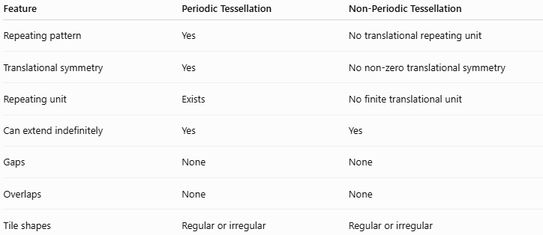
Feature | Periodic Tessellation | Non-Periodic Tessellation
Repeating pattern | Yes | No translational repeating unit
Translational symmetry | Yes | No non-zero translational symmetry
Repeating unit | Exists | No finite translational unit
Can extend indefinitely | Yes | Yes
Gaps | None | None
Overlaps | None | None
Tile shapes | Regular or irregular | Regular or irregular
The distinction is therefore based on global repetition, not on whether the individual tiles are regular.

One-Dimensional vs Two-Dimensional Periodicity
# Source: AI Source: Provided by: [Data Path: Persons Table -> ID Column: 1, Name_En Column: Motasem Essam] -> From: [ChatGPT] on [7/25/2026]
One-Dimensional Periodicity
The pattern repeats in only one direction.
A B A B A B A B
→ → → → → → →
Two-Dimensional Periodicity
The pattern repeats independently in two directions.

A B A B
B A B A
A B A B
B A B A
A plane tessellation is normally considered periodic when it has two independent translation vectors that reproduce the entire pattern.

Fundamental Region
# Source: AI Source: Provided by: [Data Path: Persons Table -> ID Column: 1, Name_En Column: Motasem Essam] -> From: [ChatGPT] on [7/25/2026]
A Fundamental Region is a region whose translations can generate the entire tessellation.
If the translation vectors are:
$$u$$
and
$$v$$
then repeated translations can generate points of the pattern using:
$$\boxed{mu+nv}$$
where:
$$m,n∈Z$$
The vectors $u$and $v$generate the translation lattice of the periodic tessellation.

Wallpaper Patterns
# Source: AI Source: Provided by: [Data Path: Persons Table -> ID Column: 1, Name_En Column: Motasem Essam] -> From: [ChatGPT] on [7/25/2026]
Periodic patterns covering the plane are closely related to the mathematical classification of wallpaper groups.
There are:
$$\boxed{17\text{ wallpaper groups}}$$
These classify the possible two-dimensional repeating symmetry patterns according to combinations of:
- Translation
- Rotation
- Reflection
- Glide reflection
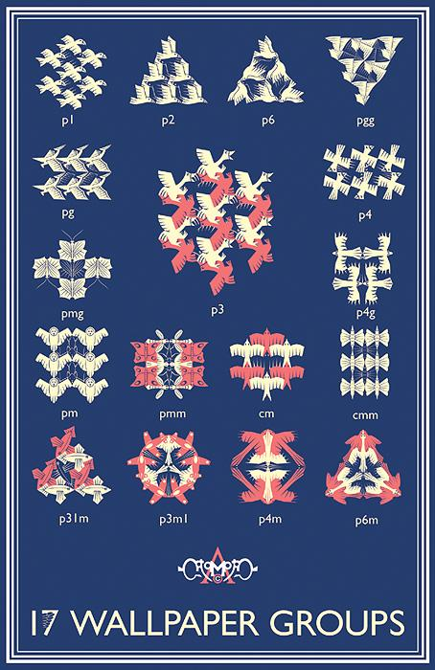
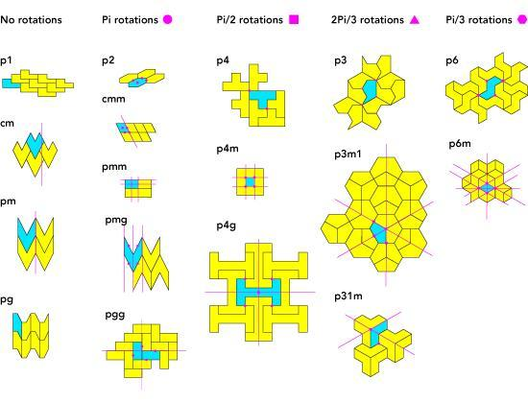
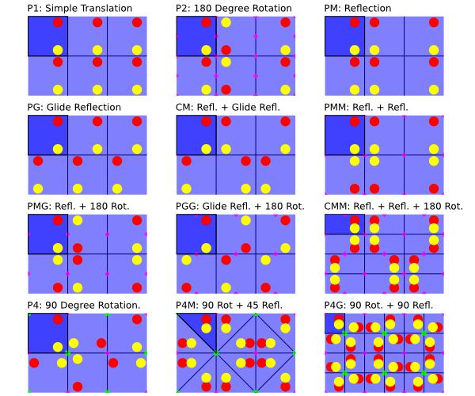
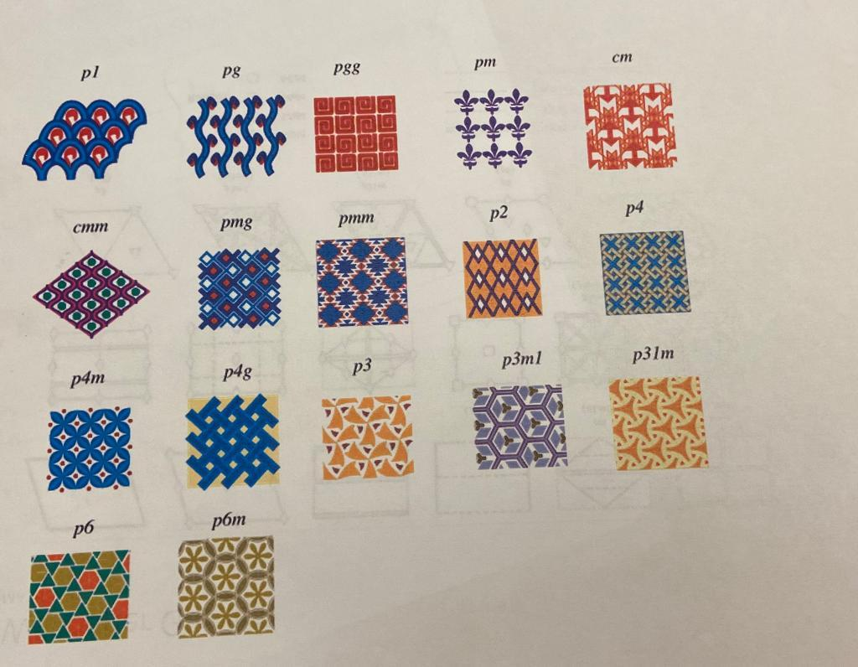
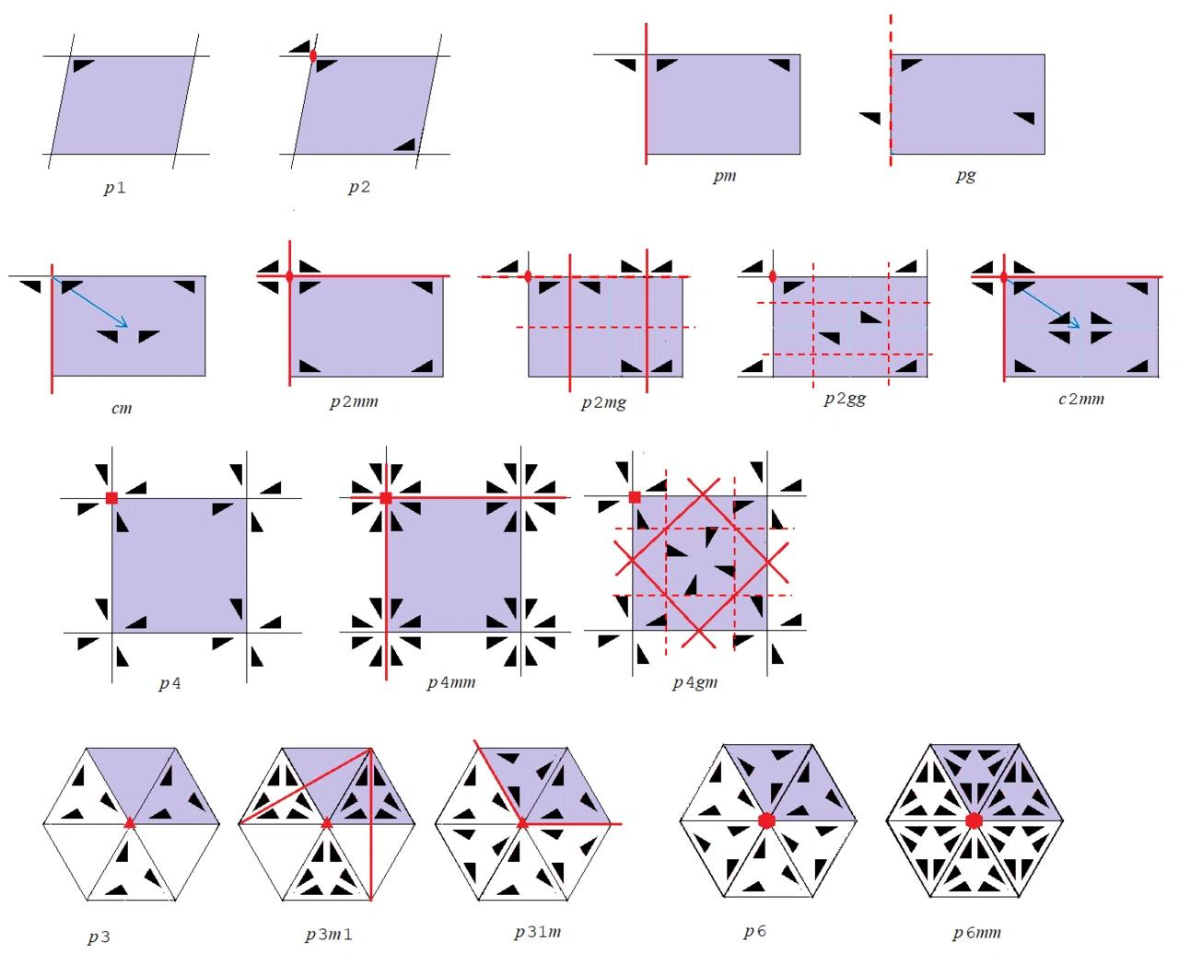
This is a more advanced classification of periodic plane patterns.

Examples

Example 1 — Square Pattern
# Source: AI Source: Provided by: [Data Path: Persons Table -> ID Column: 1, Name_En Column: Motasem Essam] -> From: [ChatGPT] on [7/25/2026]
A square grid repeats horizontally and vertically.
Therefore:
$$\boxed{\text{Square Tessellation = Periodic}}$$

Example 2 — Hexagonal Pattern
# Source: AI Source: Provided by: [Data Path: Persons Table -> ID Column: 1, Name_En Column: Motasem Essam] -> From: [ChatGPT] on [7/25/2026]
Regular hexagons repeat across the plane.
Therefore:
$$\boxed{\text{Hexagonal Tessellation = Periodic}}$$

Example 3 — Repeating Irregular Tiles
# Source: AI Source: Provided by: [Data Path: Persons Table -> ID Column: 1, Name_En Column: Motasem Essam] -> From: [ChatGPT] on [7/25/2026]
Suppose an irregular tile is repeated using the same translation vector:
$$v=\left(a , b\right)$$
Then:
$$T_{v}\left(P\right)=P$$
and the tessellation is periodic.

Periodic Does Not Mean Identical Tiles
# Source: AI Source: Provided by: [Data Path: Persons Table -> ID Column: 1, Name_En Column: Motasem Essam] -> From: [ChatGPT] on [7/25/2026]
A common misconception is:
Every periodic tessellation must use identical tiles.
This is not true.
A periodic tessellation can contain several different tiles as long as the complete arrangement repeats.
For example:
A B C A B C A B C
The individual tiles are not all identical, but the sequence repeats.
Therefore:
$$\boxed{\text{Periodic}⇒\text{Repeating Pattern}}$$
but not:
$$\boxed{\text{Periodic}⇒\text{One Tile Type}}$$

Relationship with Other Tessellation Classifications
# Source: AI Source: Provided by: [Data Path: Persons Table -> ID Column: 1, Name_En Column: Motasem Essam] -> From: [ChatGPT] on [7/25/2026]
These classifications describe different properties of a tessellation.
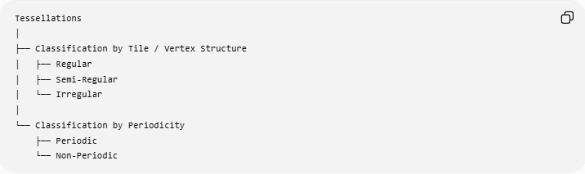
Tessellations
│
├── Classification by Tile / Vertex Structure
│ ├── Regular
│ ├── Semi-Regular
│ └── Irregular
│
└── Classification by Periodicity
├── Periodic
└── Non-Periodic
Therefore, a tessellation can simultaneously be:
- Regular + Periodic
- Semi-Regular + Periodic
- Irregular + Periodic
- Irregular + Non-Periodic
This makes Periodic Tessellation better understood as a classification by pattern repetition, rather than as a direct alternative to Regular, Semi-Regular, and Irregular Tessellation.

Real-World Applications
# Source: AI Source: Provided by: [Data Path: Persons Table -> ID Column: 1, Name_En Column: Motasem Essam] -> From: [ChatGPT] on [7/25/2026]
Periodic tessellations occur in:
- Floor and wall tiles
- Wallpaper
- Brick patterns
- Fabrics
- Architectural decoration
- Repeating ornaments
- Crystal structures
- Material science
- Computer graphics
- Surface patterns

Classification for Your Geometry Structure
# Source: AI Source: Provided by: [Data Path: Persons Table -> ID Column: 1, Name_En Column: Motasem Essam] -> From: [ChatGPT] on [7/25/2026]
I recommend organizing it as:
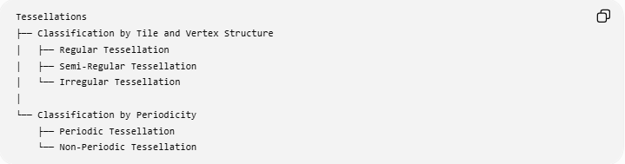
Tessellations
├── Classification by Tile and Vertex Structure
│ ├── Regular Tessellation
│ ├── Semi-Regular Tessellation
│ └── Irregular Tessellation
│
└── Classification by Periodicity
├── Periodic Tessellation
└── Non-Periodic Tessellation
This avoids treating Periodic as if it were mutually exclusive with Regular, Semi-Regular, or Irregular.

Key Points
# Source: AI Source: Provided by: [Data Path: Persons Table -> ID Column: 1, Name_En Column: Motasem Essam] -> From: [ChatGPT] on [7/25/2026]
- A Periodic Tessellation has a repeating pattern.
- Its defining symmetry is translation symmetry.
- It has a finite repeating unit or fundamental region.
- A periodic tessellation can use one or multiple tile types.
- Its tiles can be regular or irregular.
- Regular and semi-regular tessellations are periodic.
- Irregular tessellations can also be periodic.
- Two-dimensional periodic patterns are related to the 17 wallpaper groups.

Conclusion
# Source: AI Source: Provided by: [Data Path: Persons Table -> ID Column: 1, Name_En Column: Motasem Essam] -> From: [ChatGPT] on [7/25/2026]
A Periodic Tessellation is a tessellation whose entire pattern repeats through translation. The concept describes the global repetition and translational symmetry of the pattern, rather than the shape of its individual tiles. Therefore, periodicity should be treated as an independent classification dimension alongside Regular, Semi-Regular, and Irregular Tessellations.

